SOFE 3490: Software Project Management

Lab 3

Course Project: **Music Hub**

|  |  |
| --- | --- |
| **Student Name** | **Student ID** |
| Umar Ehsan | 100634240 |
| Diba Shojaeigoradel | 100621768 |
| Ryuji Komai | 100631883 |

**Project: Music distribution**

**1.0 Project Estimation:**

The estimated effort and duration for the music hub project is calculated using the COCOMO model. For the purposes of the model, we identify our project as an Organic project due to the following:

* The project domain consists of previous works which are very similar.
* Knowledge of development techniques is well understood with team members having nominal experience with the technology needed.
* The project team is small and thus requires less complexity.

In order to calculate the project effort estimates we use the basic COCOMO model as described below.

The basic COCOMO model calculates project effort in person-months using the following formula:

E = a (KLOC) ­­b where E is effort calculated in person months

D = c (E) d where D is duration calculated in months

Where KLOC is the thousand lines of code and a, b, c, d are constants.

For an organic project, a = 2.4, b = 1.05, c = 2.5, d = 0.38

Since the project will involve both a web-app and a mobile app, and there are previous solved problems with libraries available for this problem, the estimated lines of new code is around 3000 (web) + 1000 (mobile) = 4000 lines of code.

Hence E = 2.4 * (4)1.05 = 10.3 person months

And D = 2.5 * (10.3) 0.38 = 6 months

Hence the project is estimated to take 6 months with an effort of 10.3 person months.

**2.0 Project Activity Diagram:**

The project activity diagram along with an activities’ chart is shown below.

|  |  |  |
| --- | --- | --- |
| **Activity** | **Duration** | **Earliest Start** |
| Hardware selection (for development and server deployments) | 2 weeks | Week 0 |
| Software selection (development environment, libraries, testing framework) | 3 weeks | Week 0 |
| Recruiting Staff | 1 week | Week 0 |
| Hardware installation | 1 week | Week 2 |
| Web application coding | 8 weeks | Week 3 |
| Mobile application coding | 6 weeks | Week 3 |
| Database installation | 4 weeks | Week 3 |
| Unit testing | 3 weeks | Week 11 |
| Integration testing | 2 weeks | Week 14 |
| Documentation and development of user support manuals | 2 weeks | Week 11 |
| User Acceptance Testing | 1 week | Week 16 |
| Training and Deployment | 1 week | Week 16 |

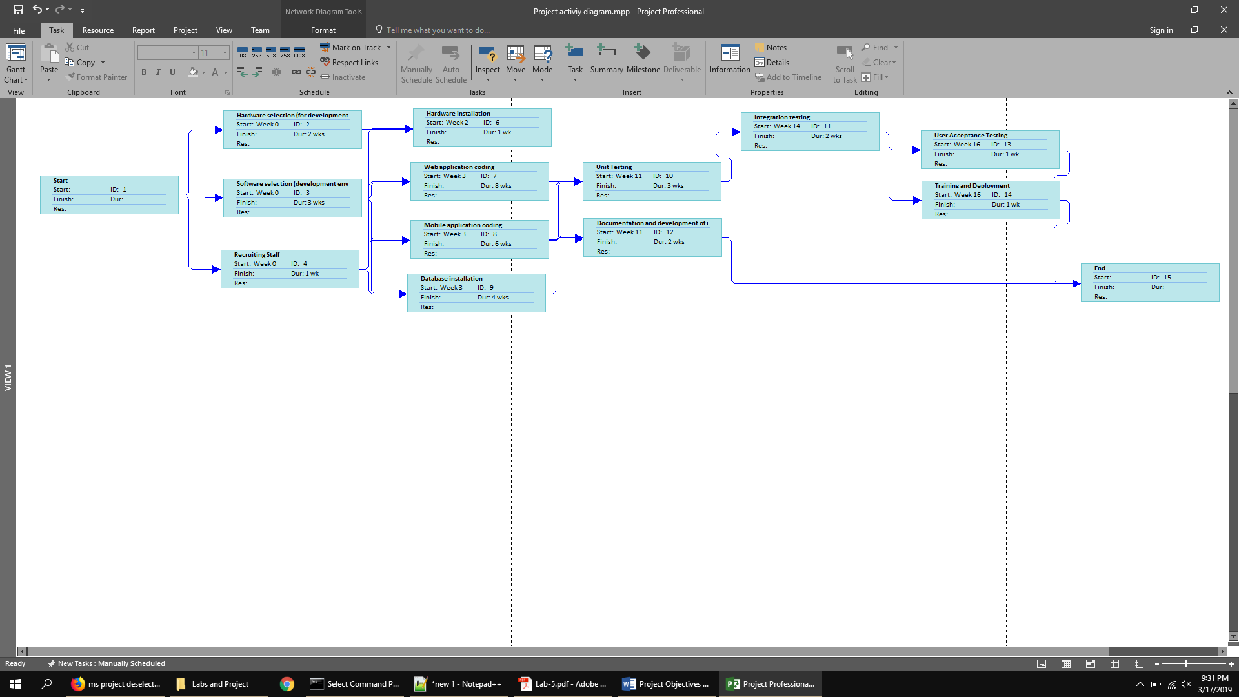**3.0 Project Risks and Mitigation Strategies:**